March 3rd #WorldBDDay is almost here!
World Birth Defects Day
NEWSLETTER

February 2020

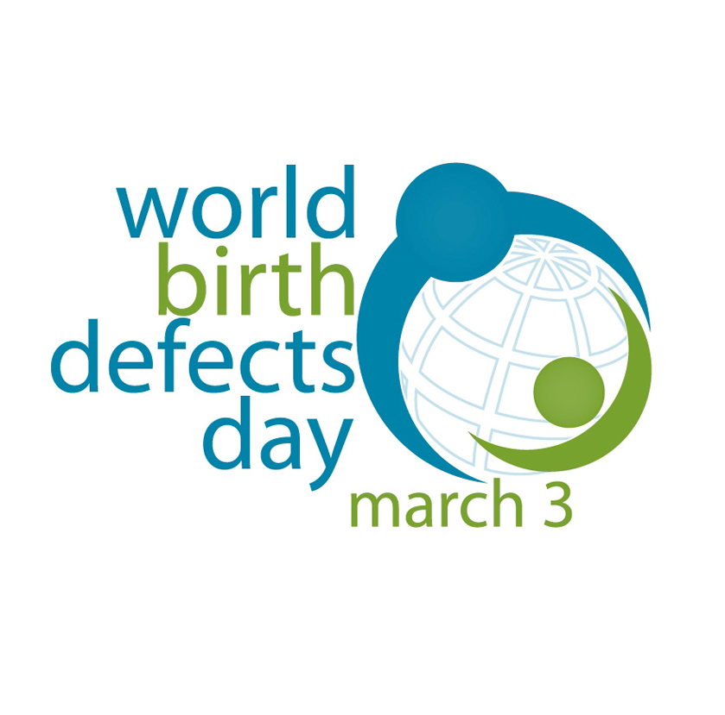  Are you ready for #WorldBDDay?  Join us for:  - I CARE campaign  - Twitter Chat  - Facebook/Instagram LIVE  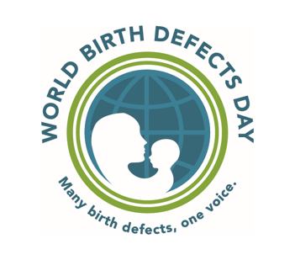  Remember:  - Every WBDD Partner should increase awareness on birth defects through their website and social media accounts!  - Keep the WBDD logo on your website.  - Keep us informed on your activities!  - Visit www.worldbirthdefectsday.org to stay updated. |  | WE CARE…  This year, we are showing how much WE CARE...  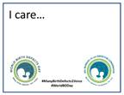  Calling all supporters of birth defects research and prevention around the world to download and print this sign, fill it out with why they care about birth defects prevention and research, and post a picture of themselves holding it on March 3rd! Don’t forget to add #WorldBDDay and #ManyBirthDefects1Voice to the post!  Get the sign and more info @ https://www.worldbirthdefectsday.org/i-care-campaign.  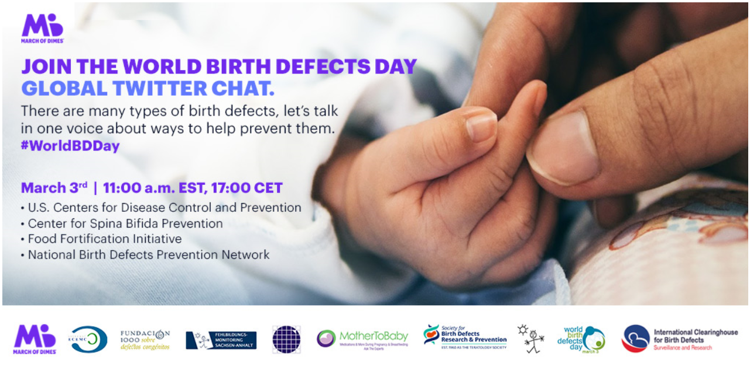  Join us for a #WorldBDDay Global Twitter chat!  On March 3rd at 11:00 EST, 17:00 CET, join us during the Twitter Chat as one voice to raise awareness about birth defects. To prepare, get the bilingual script and questions here.  Even if you cannot join us live, please schedule a tweet using #WorldBDDay at this time.  Coming to you live from Instagram and Facebook!  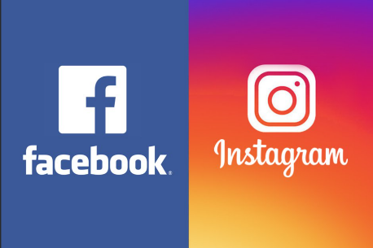  On March 3rd at 10:00 PST, 13:00 EST, 19:00 CET, MotherToBaby is going live to answer questions about birth defects!  Ways for partner organizations to participate and promote:  - Follow @MotherToBaby on Facebook(FB) or @mothertobabyotis on Instagram (or both). You might get a notification at the live broadcast start time. Or, go to MotherToBaby’s profile on either Facebook or Instagram at the broadcast start time (10:00 PST, 13:00 EST, 19:00 CET).  - On FB, the live video should be playing at the top of MotherToBaby’s page. On Instagram, you will see a small badge around the story circles at the top of the screen that says “live.” Tap to enter the live stream. The person streaming will know that you are tuning in.  1  - With either platform, once you are watching the live stream, you can comment or ask questions, the same way you’d engage with a non-live post. Make sure to do this from your organization’s official FB or Instagram account. Or you can join via your personal accounts and mention the organization/country you’re joining the live broadcast from.  - Have your organization’s page “RSVP” as “going” on the MotherToBaby Facebook event created to promote the live panel. Then share it with your followers: https://www.facebook.com/events/213655426471361/  - Share our link to our Facebook/Instagram Live article: http://bit.ly/2020FBINSTAlive  Got stories?  We are looking for stories to share to raise awareness about birth defects!  - Do you have a story related to the activities of your organization?  - Do you work with families and can feature their story about having a family member born with a birth defect?  - Are you a health care provider or know of health care providers who might want to share their stories about the impact of birth defects?  Please send your stories to see the suggestions on centre@icbdsr.org so that we can share and help raise awareness!  Be an active WBDD Partner!  - Visit the “Prior Activities” page on the WBDD website at https://www.worldbirthdefectsday.org/activities/ to find event ideas!  - If you host an event, make sure to use #WorldBDDay #ManyBirthDefects1Voice #DiaMundialDefectosCongenitos #MuchosDefectos1Voz. Also, email centre@icbdsr.org so we are aware and can help promote.  For more information  Visit: www.worldbirthdefectsday.org  Email: centre@icbdsr.org  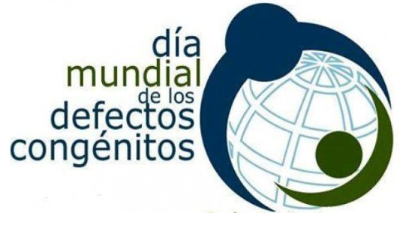  2
