World Birth Defects Day Toolkit  - Resources you can use and share | 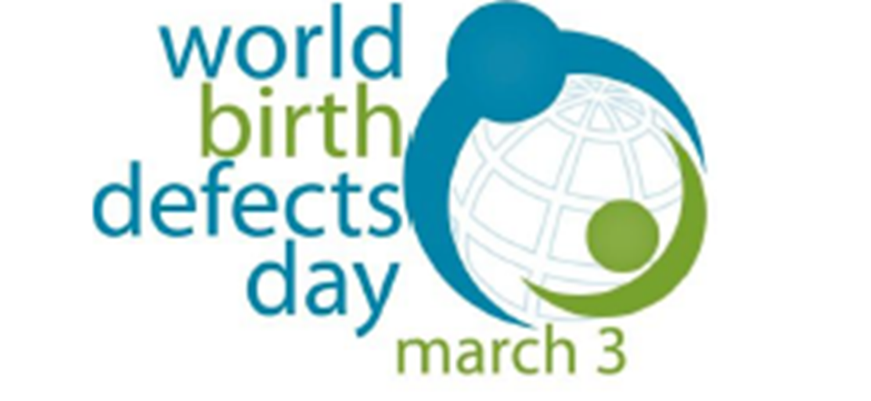
World Birth Defects Day aims to use our collective voice in raising awareness for all birth defects and improve care and treatment (#manybirthdefects1voice). This 2021 World Birth Defects Day Toolkit has been developed to help you with your awareness activities.
Every year, about 3-6% of infants globally (~ 8 million infants), are born with a serious birth defect, or congenital anomaly. Birth defects are a leading contributer to the global burden of infant mortality and result in life-long mental and physical disabilities. However, many birth defects are preventable. By promoting awareness of birth defects, we can increase opportunities for the prevention of birth defects and improve infant outcomes worldwide.

  - How to Use This Toolkit
We provide a list of ideas and activities that can be done individually or in coordination with partners or other organizations. We invite you to use the toolkit to design your own promotions, pick and choose relevant content for your audiences, and copy or adapt contents to take advantage of particular news or issues in your community.
- WBDD Flyer
- WBDD presentation
- Key messages: Many Birth Defects, One voice.
  - These resources can serve as a foundation for your messaging.
- Activities: List of suggested activities for World Birth Defects Day
- Sample news release: Pitch a news release to your local newspapers to amplify these messages
- Social media resources
  - Sample messages
  - Tools, such as how to create QR code

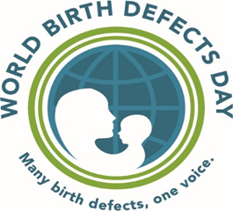
Flyer and Presentation
- World Birth Defects Day Flyer – English, Spanish
- Presentation – English, Spanish

Key Messages
These messages and resources can be shared with others on World Birth Defect Day as a way to promote awareness about birth defects and how to prevent them. Feel free to tailor these messages in a way that is relevant to your community or target audience.
- Birth defects are common, costly and critical
- Birth defects affect nearly 8 million infants, or 6% of all infants, born globally each year.
- Birth defects cause 1 out of every 5 deaths in infants.
- Birth defects cause lifelong disabilities and challenges.
- Each year, birth defects cost the United States healthcare system $2.6 billion.
- Resources:
- Link to infographic about birth defects: https://www.cdc.gov/ncbddd/birthdefects/infographic.html
- Global burden of birth defects: https://www.marchofdimes.org/mission/march-of-dimes-global-report-on-birth-defects.aspx
- Taking 400ug of folic acid daily before and during pregnancy can prevent birth defects
- Folic acid can help prevent birth defects of the brain and spine.
- Because the brain and spine form before many women know they are pregnant, it is important for all women of childbearing age to consume folic acid.
- Eat a diet rich in folate. Foods that have folate include certain fruits and vegetables, nuts, and folate-fortified breads and cereals.
- Resources
- Folic acid recommendations: https://www.cdc.gov/ncbddd/folicacid/recommendations.html
- Information about folic acid: https://www.marchofdimes.org/pregnancy/folic-acid.aspx
- Folic acid safety: https://www.cdc.gov/ncbddd/folicacid/faqs/faqs-safety.html

- Consult with your healthcare provider before starting or stopping any medications during pregnancy.
- Planning how to take care of your health conditions before you become pregnant can keep you and your developing baby healthy.
- Some medications are not safe to take during pregnancy.
- There may be benefits to continuing taking your current medications.
- Resources
  - Medications and pregnancy: https://www.cdc.gov/pregnancy/meds/treatingfortwo/index.html
- Attend prenatal care appointments and become up-to-date on all vaccines.
- Vaccines help protect you and your baby.
- Antibodies that your body produces after receiving the Tdap vaccine during pregnancy protects your baby from whooping cough and tetanus.
- Partners and family members who will help take care of the baby should become up-to-date on vaccines to help protect the baby from serious diseases until the baby can receive his or her own vaccines.
- Pregnant women may choose to receive the COVID-19 vaccine. Talk to your healthcare provider if you are considering getting this vaccine.
- Resources
- COVID vaccine and pregnancy: https://www.cdc.gov/coronavirus/2019-ncov/vaccines/recommendations/pregnancy.html
- COVID vaccine and pregnancy: https://www.acog.org/clinical/clinical-guidance/practice-advisory/articles/2020/12/vaccinating-pregnant-and-lactating-patients-against-covid-19
- Tdap vaccine: https://www.cdc.gov/pertussis/pregnant/mom/get-vaccinated.html
- Flu vaccine: https://www.cdc.gov/flu/highrisk/qa_vacpregnant.htm?CDC_AA_refVal=https%3A%2F%2Fwww.cdc.gov%2Fflu%2Fprevent%2Fqa_vacpregnant.htm
- Vaccinations and pregnancy: https://www.marchofdimes.org/pregnancy/vaccinations-and-pregnancy.aspx
- Avoid smoking, drinking alcohol, and taking other drugs during pregnancy.
- There is no safe amount of alcohol to drink during pregnancy.
- Drinking alcohol during pregnancy can result in lifelong physical and intellectual disabilities for your baby.
- Smoking during pregnancy can cause certain birth defects.
- If you are trying to get pregnant or are pregnant and take drugs, get help! A healthcare provider can help with you get counseling, treatment, and other support services.
- Resources
- Substance use in pregnancy: https://www.who.int/substance_abuse/activities/pregnancy_substance_use/en/
- Alcohol during pregnancy: https://www.marchofdimes.org/pregnancy/alcohol-during-pregnancy.aspx
- Marijuana during pregnancy: https://www.cdc.gov/marijuana/factsheets/pregnancy.htm
- Birth defects surveillance and research can help improve pregnancy and infant outcomes.
- Establishing surveillance systems enables regions and countries to get accurate and up-to-date estimates of birth defects.
- More birth defects research is needed to identify causes of birth defects so that they can be prevented and treated.

Sample WBDD Activities
How can you help spread awareness about World Birth Defect Day? Use the ideas listed below and/or create your own action plan!
- Be active on social media! Use #WorldBDDay or #Manybirthdefects1voice.
- Create posts on Facebook, Twitter, and Instagram that highlight messages about birth defects! See examples of key messages in the Resource page of this toolkit.
- Before March 3, let others know that World Birth Defects Day is coming up!
  - Sample message: Join us on March 3rd for World Birth Defects Day to improve birth defect prevention and research worldwide!
- Follow, share/retweet, comment, and link posts by fellow birth defects prevention advocates on social media platforms.
- Add links from one of the Resources in this toolkit to support your message and provide viewers with more information about birth defects.
- Share stories about the impact of birth defects on you or someone you know.
- Publicize World Birth Defects Day on your organization’s website
Feature the WBDD logo and information on your website’s home page or create a WBDD page on your website. Click here for an example from the March of Dimes: https://www.marchofdimes.org/mission/world-birth-defects-day.aspx
- Add the World Birth Defect Day logo and hashtag in your email signature
https://www.worldbirthdefectsday.org/use-wbdd-logo/
- Organize an event to celebrate World Birth Defect Day
- Host a webinar, conference, lunch and learn, or workshop about birth defects.
- Organize a social event (ex. 5K run or a dinner).
- Create flyers or share your event on social media.
- Disseminate information about your organization’s activities in support of World Birth Defect Day
- Write an article or blog for a local newspaper, magazine, or other online resource. See sample below.
- Post on social media about the events that your organization is doing for World Birth Defects Day. Share the website www.worldbirthdefectsday.org
- Share about your activities with us! Send what you did to centre@icbdsr.org to be shared on the website!

Sample News Release

“Many Birth Defects, One Voice”: World Birth Defects Day 2021
[City, Country]--- Every year, 8 million infants globally are born with a serious birth defect. In [country], 1 out of every [X] babies are born with a birth defect. Birth defects are a leading cause of infant mortality and for babies who do survive, birth defects result in lifelong physical and intellectual disabilities. That’s why [Organization name] is joining other birth defect prevention organizations, including the World Health Organization, March of Dimes, and the Centers for Disease Control and Prevention, to increase awareness about birth defects on March 3rd, World Birth Defects Day.
Not all birth defects can be prevented, but women can increase their chances of having a healthy baby by adopting healthy behaviors before becoming pregnant and during pregnancy. For example, eating a healthy diet, including taking 400ug of folic acid daily, receiving prenatal care, staying up-to-date on vaccines, and avoiding alcohol and smoking all reduce the risk of birth defects.
In order to improve outcomes of infants, surveillance programs and birth defect research is essential. Surveillance provides accurate estimates of the number of infants with birth defects and can track factors that may contribute to birth defects. This allows for public health organizations and researchers to identify opportunities for interventions that can lead to better health outcomes.
Join [Organization] on March 3rd to promote awareness about birth defects by [insert list of activities that organization is hosting.] To learn more about what [Organization] is doing on March 3, visit [organization website]. To learn more about World Birth Defects Day, visit www.worldbirthdefectsday.org.

Sample Social Media Messages
Facebook Sample Message
More than 8 million babies worldwide are born with a birth defect each year. Birth defects cause 1 out of every 5 deaths in infants and lead to lifelong disabilities and challenges for those who do survive. Today, we join other organizations in raising awareness about birth defects. Learn more at www.worldbirthdefectsday.org
Many birth defects can be prevented and treated. Help raise awareness about birth defect prevention on March 3rd on World Birth Defects Day! Learn more at www.worldbirthdefectsday.org
Instagram Sample Message
More than 8 million babies worldwide are born with a #birthdefect each year. Birth defects cause 1 out of every 5 deaths in infants and lead to lifelong disabilities and challenges for those who do survive. Today, on we join other organizations in raising awareness about birth defects. Learn more at www.worldbirthdefectsday.org #WorldBDday #manybirthdefects1voice
Many #birth defects can be prevented and treated. Help raise awareness about birth defect #prevention on March 3rd on World Birth Defects Day! Learn more at www.worldbirthdefectsday.org #WorldBDday
Twitter Sample Message
More than 8 million babies worldwide are born with a #birth defect each year. Today on #WorldBDDay, we join other organizations in raising awareness about birth defects. Learn more at www.worldbirthdefectsday.org
Many birth defects can be prevented and treated. Help raise awareness about birth defect #prevention on March 3rd on World Birth Defects Day! Learn more at www.worldbirthdefectsday.org #WorldBDDay

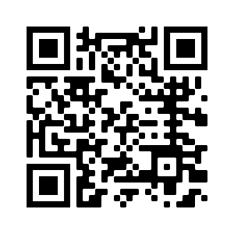
Let us know what you are doing!
❶ Use #WorldBDDay #ManyBirthDefects1Voice #DiaMundialDefectosCongenitos #MuchosDefectos1Voz.
❷ Email centre@icbdsr.org so we are awareness and can help promote your activities.

