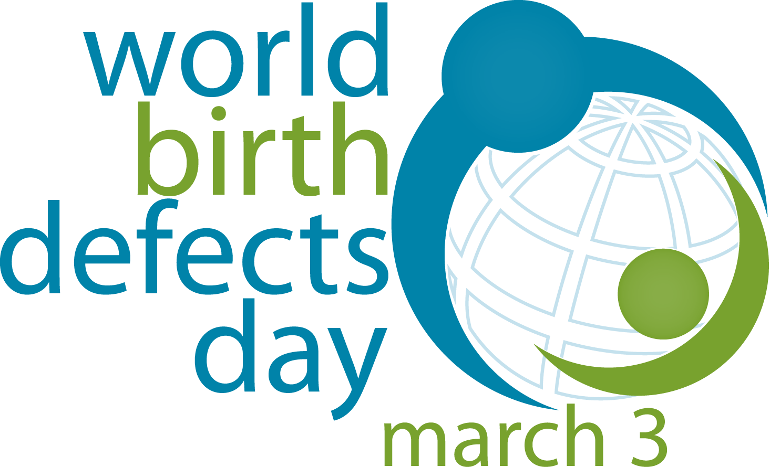
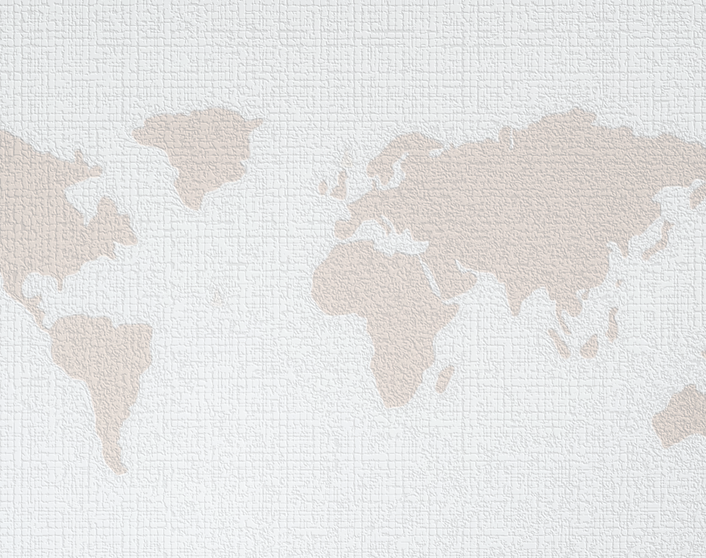

World Birth Defects Day 2024 Resource Toolkit

Contents
How to Use These Resources 1
Social Media Toolkit & Promotional Materials 1
2024 Theme & Key Messaging 2
Sample WBDD Activities 7
Sample News Release 8
Sample Social Media Messages 10

How to Use These Resources
World Birth Defects Day (WBDD) aims to use a collective voice in raising awareness of all birth defects and improve care and treatment. These 2024 WBDD resources can help you with your awareness activities.
We provide a list of ideas and activities that can be done individually or in coordination with partners and organizations. We invite you to use these resources to design relevant content that is meaningful for your audiences and communities.

Social Media Toolkit & Promotional Materials
- WBDD 2024 Social Media Toolkit
- WBDD 2024 Logo
- WBDD 2024 Banner
- WBDD 2024 Flyer
- WBDD 2024 8 Second Challenge Instructions

2024 Theme & Key Messaging
The 2024 WBDD (#WorldBDDay) theme is “Every Journey Matters.” Birth defects affect individuals, family, friends, and communities. That’s why #EveryJourneyMatters.

While “birth defect” is a medical term, it doesn’t mean that an individual is “defective.” Instead, it refers to health conditions that develop in a baby before birth that affects the structure or function of their body. Join us on March 3rd for #WorldBDDay to raise one voice across the globe for birth defect awareness.

Additionally, the messages and resources listed below can be shared on WBDD to promote awareness for birth defects surveillance, research, and prevention. Tailor these messages to fit the needs of your communities and audiences.

- Birth defects are common, costly, and critical.
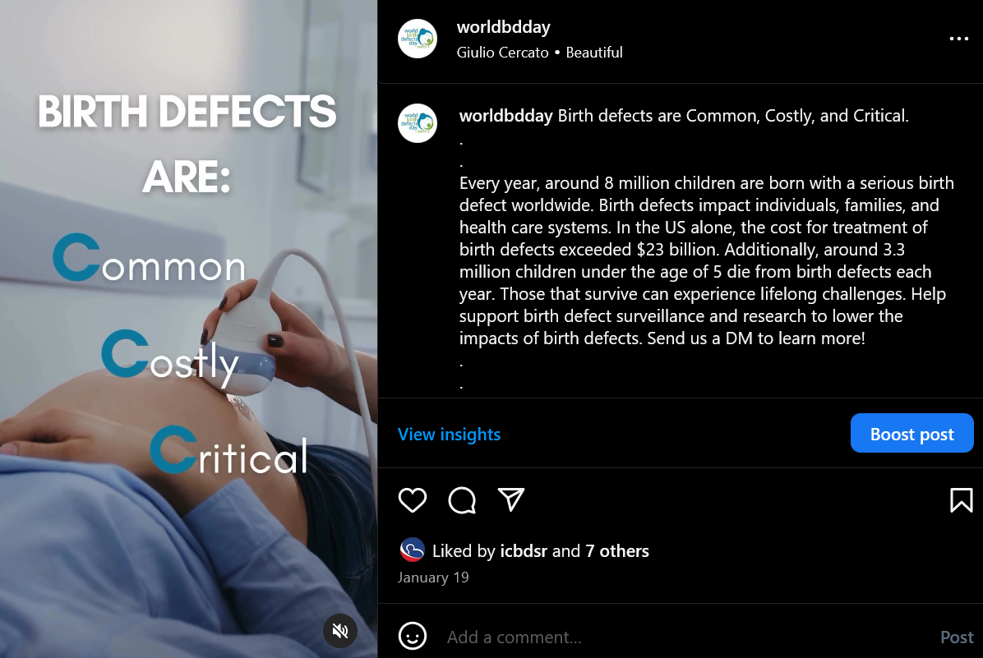
- Birth defects affect nearly 8 million infants, or 6% of all infants, born globally each year.
- Birth defects cause 1 out of every 5 deaths in infants.
- Birth defects cause lifelong disabilities and challenges.
- Each year, birth defects cost the United States healthcare system about $2.6 billion.
Resources:
- Link to infographic about birth defects: https://www.cdc.gov/ncbddd/birthdefects/infographic.html
- Global burden of birth defects: https://www.prevencioncongenitas.org/wp-content/uploads/2017/02/Global-report-on-birth-defects-The-hidden-toll-of-dying-and-disabled-children-Full-report.pdf
- Taking 400ug of folic acid daily during preconception and pregnancy can help prevent birth defects.
- Folic acid can help prevent birth defects of the brain and spine.
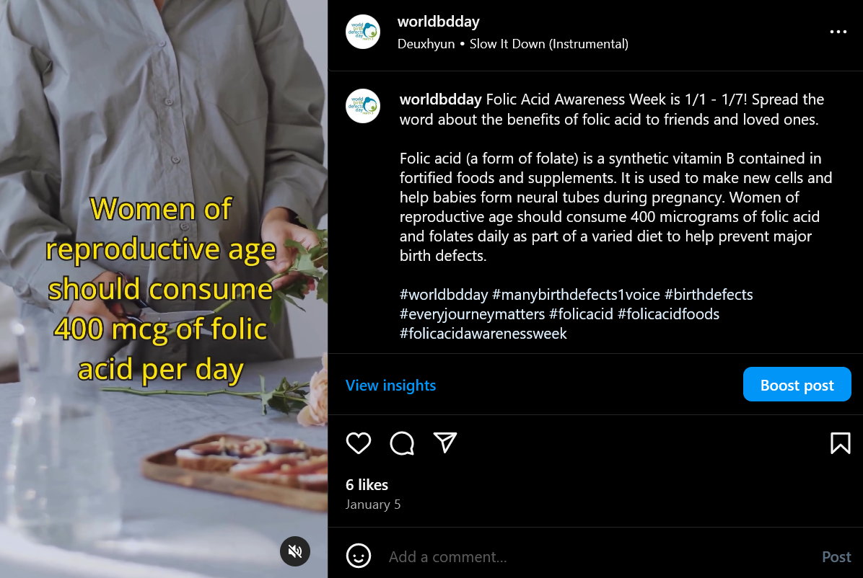
- A baby’s brain and spine form in the first 1-3 weeks of gestation. During this time, women may be unaware they are pregnant. Therefore, it is important for all women of childbearing age to consume folic acid.
- Eat a diet rich in folate. Foods that have folate include select fruits, vegetables, nuts, and folate-fortified breads and cereals.
Resources:
- Folic acid recommendations: https://www.cdc.gov/ncbddd/folicacid/recommendations.html
- Information about folic acid: https://www.marchofdimes.org/pregnancy/folic-acid.aspx
- Folic acid safety: https://www.cdc.gov/ncbddd/folicacid/faqs/faqs-safety.html

- Consult with your healthcare provider before starting or stopping any medications during pregnancy.
- Planning how to take care of your health conditions before you become pregnant can keep you and your developing baby healthy.
- Some medications are not safe to take during pregnancy.
- There may be benefits to continuing taking your current medications.
Resources:
- Medications and pregnancy: https://www.cdc.gov/pregnancy/meds/treatingfortwo/index.html

- Attend prenatal care appointments and stay up-to-date on all vaccines.
- Vaccines help protect you and your baby.
- Antibodies that your body produces after receiving the Tdap vaccine during pregnancy protects your baby from pertussis (whooping cough) and tetanus.
- Partners and family members who will help take care of newborns should be up-to-date on vaccines to protect the baby from serious diseases until the baby can receive his/her own vaccines.
- Pregnant women may choose to receive the COVID-19 vaccine. Talk to your healthcare provider if you are considering getting this vaccine.
Resources:
- COVID vaccine and pregnancy: https://www.cdc.gov/coronavirus/2019-ncov/vaccines/recommendations/pregnancy.html
- COVID vaccine and pregnancy: https://www.acog.org/clinical/clinical-guidance/practice-advisory/articles/2020/12/vaccinating-pregnant-and-lactating-patients-against-covid-19
- Tdap vaccine: https://www.cdc.gov/pertussis/pregnant/mom/get-vaccinated.html
- Flu vaccine: https://www.cdc.gov/flu/highrisk/qa_vacpregnant.htm?CDC_AA_refVal=https%3A%2F%2Fwww.cdc.gov%2Fflu%2Fprevent%2Fqa_vacpregnant.htm
- Vaccinations and pregnancy: https://www.marchofdimes.org/pregnancy/vaccinations-and-pregnancy.aspx

- Avoid smoking, drinking alcohol, and taking other drugs during pregnancy.
- There is no safe amount of alcohol to drink during pregnancy.
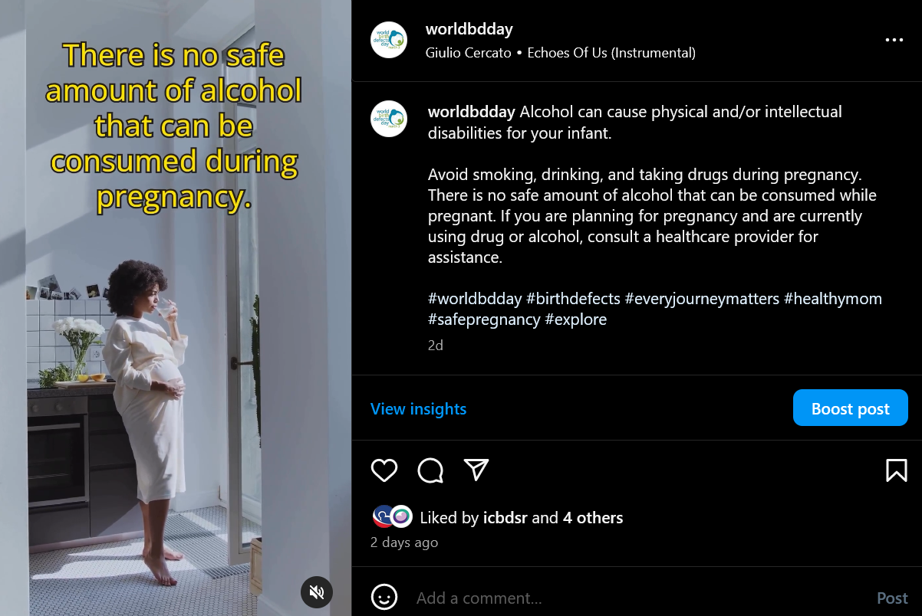
- Drinking alcohol during pregnancy can result in lifelong physical and intellectual disabilities for your baby such as fetal alcohol spectrum disorder (FASD).
- Smoking during pregnancy can cause certain birth defects.
- If you are trying for pregnancy, or are pregnant and currently taking drugs, consult a healthcare provider for assistance. Healthcare providers can connect you to counseling, treatment, and other support services.
Resources:
- Substance use in pregnancy: https://www.cdc.gov/reproductivehealth/maternalinfanthealth/substance-abuse/substance-abuse-during-pregnancy.htm
- Alcohol during pregnancy: https://www.marchofdimes.org/pregnancy/alcohol-during-pregnancy.aspx
- Marijuana use during pregnancy: https://www.cdc.gov/marijuana/health-effects/pregnancy.html
- Vaping and e-cigarette use during pregnancy: https://www.ncbi.nlm.nih.gov/pmc/articles/PMC10058591/
https://www.ncbi.nlm.nih.gov/books/NBK582524/

- Many birth defects can be treated through surgical, non-surgical and rehabilitative interventions.
- All newborns should be screened and examined for birth defects and referred to surgical or non-surgical treatment early in life.
- Families should be informed and educated about the baby’s specific birth defect and where to seek care.
- Improving access to quality care early in life is critical for saving lives and reducing disability from birth defects.

Resources:
- Early diagnosis of birth defects: https://www.paho.org/en/news/3-3-2023-birth-defects-importance-early-diagnosis
- WHO Birth defect fact sheet: https://www.who.int/health-topics/congenital-anomalies#tab=tab_1

- Persons born and living with birth defects may need lifelong care.
- Healthcare and rehabilitative services must be made universally available to persons with birth defects and related disabilities.
- Universal health coverage means that everyone should have access quality health services they need, without financial hardship.
- Persons living with a birth defect have a right to respectful lifelong care.

Resources:
- Universal health coverage: https://www.who.int/news-room/fact-sheets/detail/universal-health-coverage-(uhc)
- Birth defects and health care providers: https://www.cdc.gov/ncbddd/birthdefects/families-pcp.html
- Convention on the Rights of Persons with Disabilities: https://www.un.org/development/desa/disabilities/convention-on-the-rights-of-persons-with-disabilities/convention-on-the-rights-of-persons-with-disabilities-2.html

- Birth defects surveillance and research can help improve pregnancy and infant outcomes.
- Establishing surveillance systems enables regions and countries to collect accurate and up-to-date estimates of birth defects.
- More birth defects research is needed to identify causes of birth defects so that they can be prevented and treated.
- Surveillance programs should create pathways for referral to healthcare services needed for identified birth defects.

Sample WBDD Activities
How can you help spread awareness about World Birth Defects Day? Use the ideas listed below and/or create your own action plan. Be sure send your activities to worldbdday@gmail.com to be featured!
- Be active on social media and use #WorldBDDay #EveryJourneyMatters and #AwareneesWithoutStigma
- Create posts on Facebook, Instagram, X (formerly Twitter), and LinkedIn that highlight messages about birth defects. See examples of key messages in this Resource guide or the Social Media Toolkit.
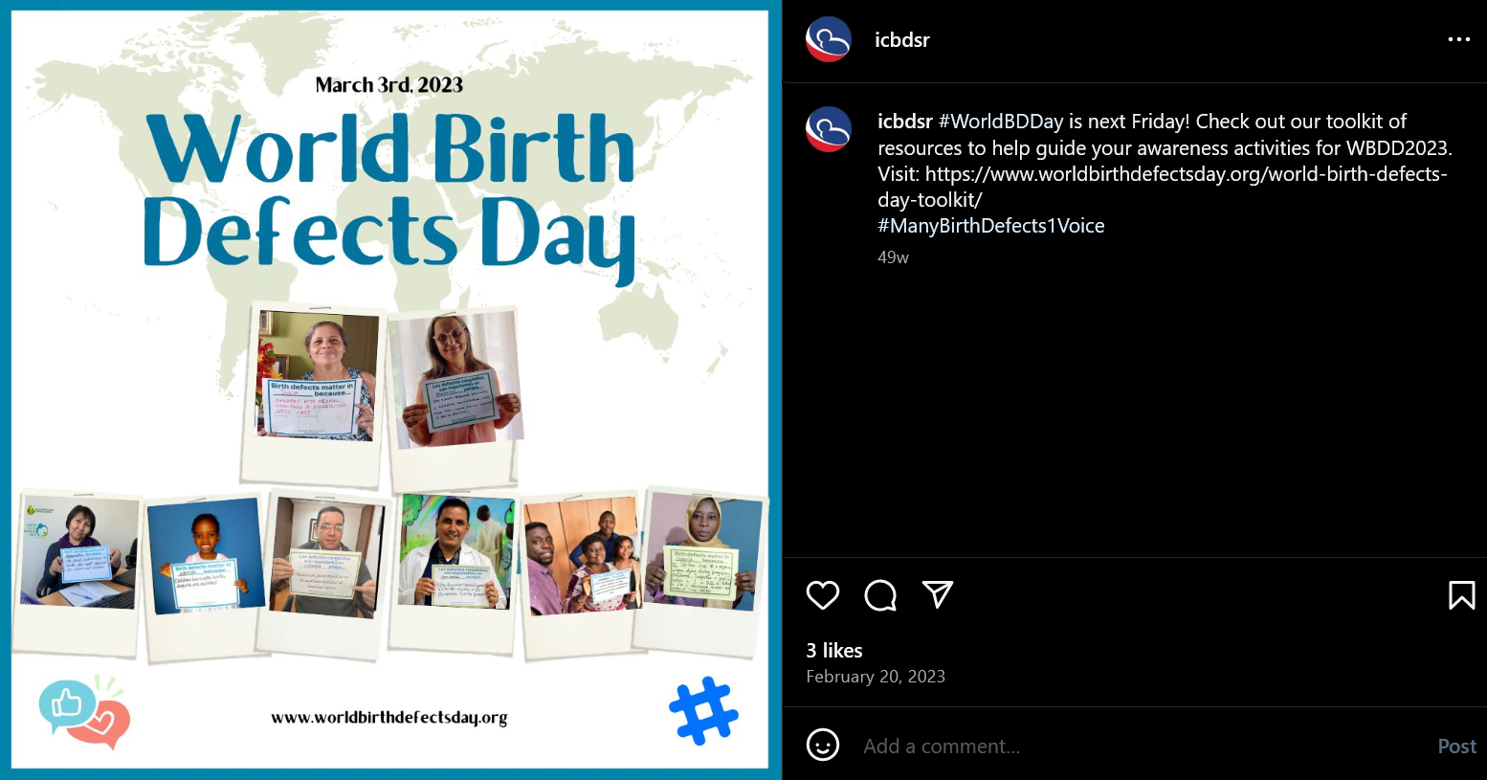
- Before March 3, let others know that World Birth Defects Day is coming up!
  - Sample message: “Join us on March 3rd for World Birth Defects Day to improve birth defect prevention and research worldwide!”

- Follow, share/retweet, comment, and link posts by fellow birth defects prevention advocates on social media platforms.
  - Ex) March of Dimes, National Birth Defects Prevention Network, International Clearinghouse for Birth Defect Surveillance and Research (ICBDSR), etc.
- Add links from one of the resources in this guide to support your message and provide viewers with more information about birth defects.
- Share stories about how birth defects impact you or someone you know.
- Publicize World Birth Defects Day on your organization’s website
- Feature the WBDD logo and information on your website’s home page or create a WBDD page on your website.

- Add the World Birth Defects Day logo and hashtag in your email signature
  - https://www.worldbirthdefectsday.org/use-wbdd-logo/

- Organize an event to celebrate World Birth Defects Day
- Host a webinar, conference, lunch and learn, or workshop about birth defects.
- Organize a social event (ex. 5K run or a dinner).
- Create flyers or share your event on social media.
- Host a live Q&A session and fundraiser.

- Share information about your organization’s activities in support of World Birth Defects Day
- Write an article or blog for a local newspaper, magazine, or other online resource. See sample below.
- Post on social media about the event(s) that your organization is doing for World Birth Defects Day. Share the website: www.worldbirthdefectsday.org.

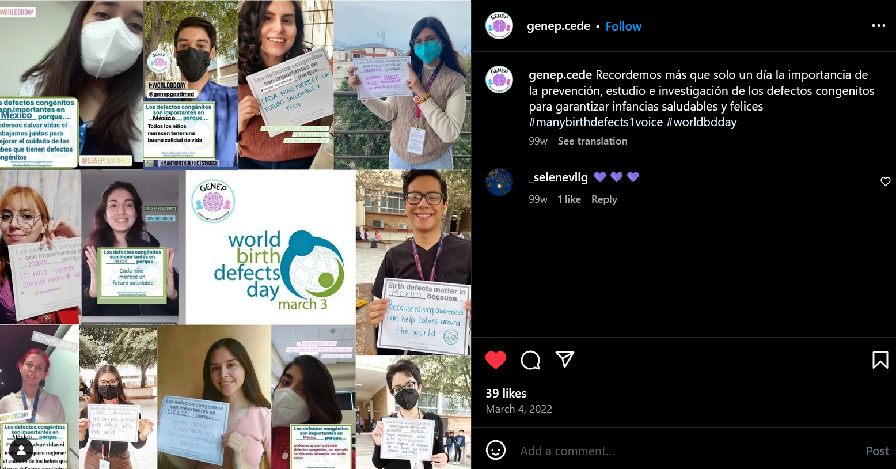

Sample News Release
“Every Journey Matters”: World Birth Defects Day 2024
[City, Country]--- Every year, 8 million infants are born globally with a serious birth defect. In [Country], 1 out of every [X] babies are born with a birth defect. Birth defects are a leading cause of infant mortality. For babies who do survive, birth defects result in lifelong physical and intellectual disabilities. That’s why [Organization Name] is joining other birth defect prevention organizations such as the World Health Organization, March of Dimes, and the Centers for Disease Control and Prevention, to increase awareness about birth defects on World Birth Defects Day on March 3rd.
Not all birth defects can be prevented, but women can increase their chances of reducing birth defects by adopting healthy behaviors during preconception and during pregnancy. Examples include: eating a healthy diet, taking 400 micrograms of folic acid daily, receiving prenatal care, staying up to date on vaccines, and avoiding alcohol and smoking.
In order to improve outcomes of infants, surveillance programs and birth defect research is essential. Surveillance provides accurate estimates of the number of infants with birth defects and can track factors that contribute to birth defects. This allows for public health organizations and researchers to identify opportunities for interventions that can lead to better health outcomes.
Join [Organization] to promote awareness about birth defects by [insert list of activities that organization is hosting]. To learn more about what [Organization] is doing on March 3, Visit [Organization’s Website]. To learn more about World Birth Defects Day, visit: www.worldbirthdefectsday.org.

Sample Social Media Messages
- More than 8 million babies worldwide are born with a serious birth defect each year. Birth defects cause 1 out of every 5 deaths in infants and lead to lifelong disabilities and challenges for those who do survive. Today on #WorldBDDay, we join with our partners in raising awareness about birth defects. Learn more at: www.worldbirthdefectsday.org.
- Many birth defects can be prevented and treated. Help raise awareness about birth defect prevention on March 3rd for #WorldBDDay! Learn more at: www.worldbirthdefectsday.org.
- Birth defect research is important to help us understand the causes of birth defects. Help us raise awareness on March 3rd for #WorldBDDay to promote more birth defect research and surveillance around the world! Learn more at: www.worldbirthdefectsday.org.
- Birth defects affect individuals, family, friends, and communities. That’s why #EveryJourneyMatters. Join us on March 3rd for #WorldBDDay to raise one voice across the globe for birth defect awareness. Learn more at: www.worldbirthdefectsday.org.
- While “birth defect” is a medical term, it doesn’t mean that an individual is “defective.” Instead, it refers to health conditions that develop in a baby before birth. Partner with us on March 3rd in raising #AwarenessWithoutStigma about birth defects. Learn more at: www.worldbirthdefectsday.org.

Let us know what you are doing!
❶ Use #WorldBDDay #EveryJourneyMatters #AwarenessWithoutStigma #DiaMundialDefectosCongenitos #TodaExperienciaImporta #ConocimientoSinEstigma
❷ Email centre@icbdsr.org so that we are aware and can help to promote your activities.

